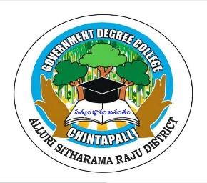
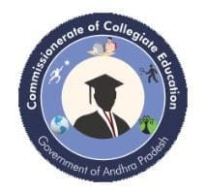
Government Degree College, Chintapalli Affiliated to Andhra University
Chintapalli, Alluri Sitharama Raju -District, AP.
Phone no: 9666739207. Email.lD: qdcchintapalli@qmail.com
TRANSFORMING INDIA
“INNOVATION, CHALLENGES & OPPORTUNITIES”

Government Degree College, Chinthapalli successfully organized a Two-Day National Seminar on TRANSFORMING INDIA
“INNOVATION, CHALLENGES & OPPORTUNITIES” on 18th and 19th August 2025. The seminar aimed to promote awareness among academicians, researchers, and students about the significance of “Transforming India” generally refers to the major social, economic, technological, and infrastructural changes happening across India to improve development, governance, and quality of life. It is often associated with modernization efforts driven by government initiatives, digital technology, infrastructure growth, and social reforms.. The seminar was organized with financial support from the PM-USHA (Pradhan Mantri Uchchatar Shiksha Abhiyan) Scheme, which enabled the institution to conduct this significant academic programme at the national level.

The seminar was conducted under the esteemed guidance of Chief Patron Dr. Narayana Bharath Gupta, IAS, Director of Collegiate Education, Andhra Pradesh. The programme also received valuable support from Patron Dr. C. Krishna, Joint Director of Collegiate Education, and Co-Patron Dr. P. V. Krishnaji, Regional Joint Director of Collegiate Education (Zones I & II). Their encouragement and administrative support greatly contributed to the successful organization of the seminar.

The seminar was presided over by Dr. M. Vijaya Bharathi, Principal of Government Degree College, Chinthapalli, who acted as the President of the Seminar. In her presidential address, she emphasized the growing importance of intellectual property rights in the present knowledge-driven world. She highlighted that protection of intellectual creations is essential to promote innovation, academic integrity, and responsible research among scholars and students.

Introduction
India is at a crucial stage in its journey of transformation. As the world’s most populous country and one of the fastest-growing major economies, India has the potential to become a global leader. At the heart of this transformation lies innovation — the ability to develop new ideas, technologies, and solutions that address local and global challenges. Innovation is not just about invention; it's about creating inclusive, sustainable, and scalable change.

Innovation
Innovation has already begun reshaping India's economy and society.
•Digital India:
•Startup Ecosystem:
•Frugal and Grassroots Innovation:

Challenges
Despite progress, several challenges limit India’s innovation potential:
1.Low R&D Investment
2.Skill Gaps and Education
3.Infrastructure Deficiency
4.Bureaucratic and Regulatory Hurdles
5.Digital and Social Divide

Opportunities
India’s strengths present enormous opportunities to accelerate innovation-led transformation:
1.Demographic Dividend
2.Global Tech Shifts
3.Green and Sustainable Innovation
4.Digital Public Infrastructure (DPI)
5.Policy Support

KEY NOTE SPEAKERS INAUGURAL SPEECH:-

Prof Adv KKK Chand , [Professor] at [Andhra University of international business], a distinguished scholar and an inspiring person who has made remarkable contributions in the field of Education.

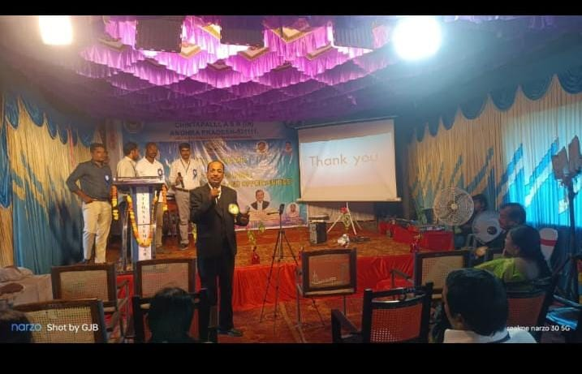

Good morning to the respected Principal Dr. M. Vijaya Bharathi, distinguished faculty members, honored guests, and my dear students.
It gives me immense pleasure to be present today at Government Degree College, Chintapalli for this important program on the theme “Transforming India: Innovation, Challenges & Opportunities.” I sincerely thank the Principal, Dr. M. Vijaya Bharathi, and the organizing team for inviting me to share my thoughts with such an enthusiastic academic community.
Our students must therefore develop not only academic knowledge but also creativity, problem-solving ability, and entrepreneurial thinking. Innovation begins with curiosity and courage—the courage to ask questions, explore new ideas, and challenge conventional thinking.
India’s greatest strength is its youth. With one of the largest young populations in the world, our country has enormous potential. If this energy is guided through education, skill development, and innovation, India can emerge as a global leader in science, technology, business, and social development.
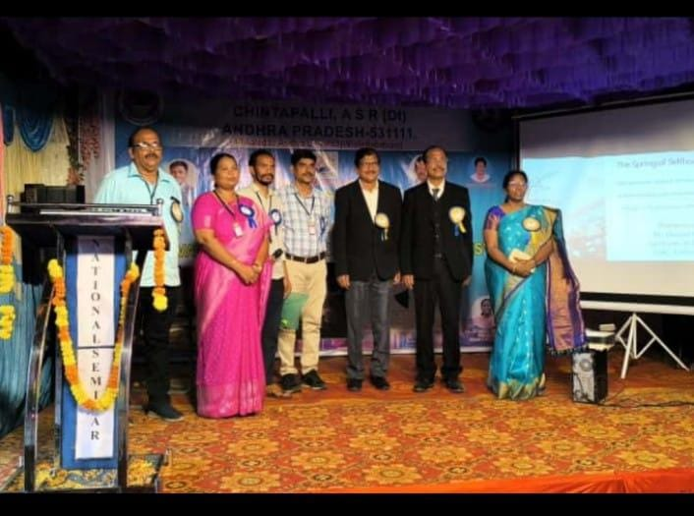
[Dr.KVK Chand], [Professor] at [Andhra University of international business], a distinguished scholar and an inspiring person who has made remarkable contributions in the field of Education.

Good morning to the respected Principal Dr. M. Vijaya Bharathi, distinguished faculty members, honored guests, and my dear students.
It is a great privilege for me to be here today at Government Degree College, Chintapalli to inaugurate this program on the theme “Transforming India: Innovation, Challenges & Opportunities.” I sincerely thank the Principal, Dr. M. Vijaya Bharathi, and the organizing committee for inviting me to interact with such bright and enthusiastic young minds.
India today is experiencing a significant phase of transformation. In the last few decades, our country has moved steadily towards becoming a global economic power. Technology, entrepreneurship, and knowledge-driven industries are reshaping the future of our nation. Innovation is no longer limited to laboratories or large corporations; it has become a vital force driving economic growth, social change, and national development.
When we speak about innovation, we must understand that it is not only about new technology. Innovation also means new ideas, new methods, and new ways of solving problems. It includes innovations in agriculture, healthcare, education, governance, and social development. Today, India has emerged as one of the

Paper Presenters:-

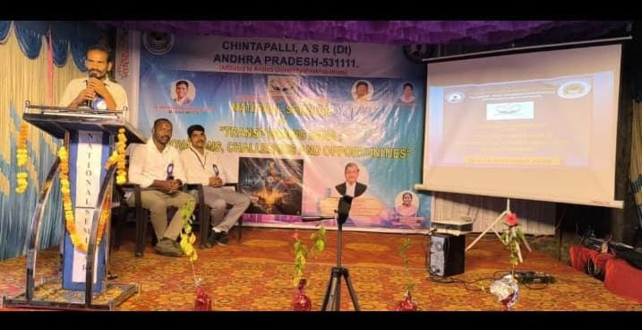

Speech on “Transforming India: Innovation, Challenges & Opportunities”
Speaker: P. Ramaraju
Lecturer in Commerce
Venue: Government Degree College, Chintapalli
In the presence of: Dr. M. Vijaya Bharathi, Principal

Good morning to our respected Principal Dr. M. Vijaya Bharathi, esteemed guest Prof. Adv. KVK Chand,KKK Chand faculty members, and my dear students.
It is a great honor for me to speak today at Government Degree College, Chintapalli on the important theme “Transforming India: Innovation, Challenges & Opportunities.”
India is passing through a remarkable period of transformation. Our country is rapidly growing in areas such as technology, digital economy, entrepreneurship, and global trade. Innovation has become the driving force behind this transformation. Today, India is known not only for its rich culture and heritage but also for its emerging role as a global hub of ideas and talent.
Innovation is not limited to scientists or engineers. It is relevant in every field—including commerce, business, agriculture, education, and social development. As commerce students, you are the future entrepreneurs, business leaders, and policymakers who will shape India’s economic future.
Institutions like Government Degree College, Chintapalli play a vital role in preparing students to face these challenges. Education should not only provide knowledge but also encourage creativity, critical thinking, and leadership skills. Students must develop confidence to start new ventures, create jobs, and contribute to society.
Before concluding, I would like to express my sincere gratitude to our Principal Dr. M. Vijaya Bharathi and the organizing team for arranging this meaningful program. Such discussions inspire students to think about their role in nation-building.
Let us all work together to build an India that is innovative, inclusive, and prosperous.

CERTICATE DISTRIBUTION:

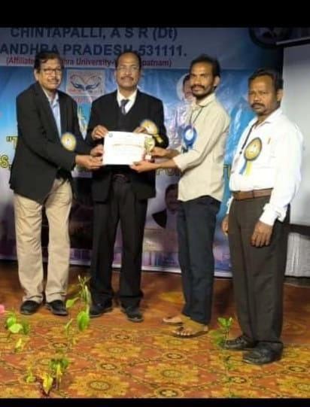

Today marks a proud and memorable moment for all the participants of this program held at Government Degree College, Chintapalli. The certificate distribution ceremony is not just a formality, but a recognition of your participation, dedication, and enthusiasm in the program on “Transforming India: Innovation, Challenges & Opportunities.”
Certificates symbolize your effort, your learning, and your active involvement in academic activities. They remind us that education is not only about classroom learning but also about participating in discussions, seminars, and events that broaden our knowledge and perspectives.
I sincerely thank our respected Principal Dr. M. Vijaya Bharathi, our distinguished guest Prof. Adv. KVK Chand, and all the faculty members for their guidance and support in making this program successful.
Once again, congratulations to all the participants. May these certificates inspire you to achieve greater success in your academic and professional journey.

Conclusion :

Conclusion / Vote of Thanks
Good evening to our respected Principal Dr. M. Vijaya Bharathi, our distinguished guest Prof. Adv. KVK Chand, faculty members, and dear students.
As we come to the end of today’s program on “Transforming India: Innovation, Challenges & Opportunities” held at Government Degree College, Chintapalli, it is time to express our sincere gratitude to everyone who contributed to the success of this event.
First and foremost, we extend our heartfelt thanks to our chief guest Prof. Adv. KVK Chand for sharing his valuable insights and inspiring thoughts on innovation and India’s transformation. His words have truly motivated our students to think creatively and aim higher.
We are deeply grateful to our respected Principal Dr. M. Vijaya Bharathi for her constant encouragement, guidance, and support in organizing this academic program.
Let us take the inspiration from today’s discussions and work together toward building an innovative, progressive, and prosperous India.
Thank you all for your presence and participation.

